Leveraging Deep Learning to Estimate the Damage Caused by Natural Disasters

Md. Rifat Ahmed   
Department of Electrical and Computer Engineering  
North South UniversityDhaka, Bangladesh  
rifat.ahmed10@northsouth.eduSaifur Rahman Rubayet  
Department of Electrical and Computer Engineering  
North South UniversityDhaka, Bangladesh  
saifur.rubayet@northsouth.eduGazi Shoaib  
Department of Electrical and Computer Engineering  
North South UniversityDhaka, Bangladesh  
gazi.shoaib@northsouth.edu

***Abstract*—Accurate estimation of natural disaster damage is crucial for effective response and recovery planning. The proposed model uses a deep learning approach to estimate the extent and severity of damage caused by natural disasters. The proposed method involves training the ResNet model on a comprehensive dataset comprising pre- and post-disaster satellite imagery, contextual information, and corresponding damage labels. With its deep layers and skip connections, the ResNet architecture enables the model to effectively learn complex spatial patterns and capture fine-grained details of the damaged areas. The results demonstrate the effectiveness of our approach in providing accurate and consistent damage estimations compared to traditional methods. This technology-driven approach has the potential to revolutionize disaster management practices by facilitating timely resource allocation and response planning, thereby reducing the impact on human lives and infrastructure.**

***Keywords—deep learning, natural disasters, damage estimation, convolutional neural networks (CNN), satellite imagery, disaster management***

# Introduction

Natural disasters, such as earthquakes, hurricanes, heavy rain leading to floods, and droughts, can cause widespread damage and pose significant threats to human life. Deep learning algorithms offer a promising solution for natural disaster management by enabling the development of systems that can predict, monitor, and respond to such events. Using deep learning algorithms, we can analyze various data sources, including weather forecasts, satellite imagery, and sensory data, to build models that accurately predict and monitor the impact of natural disasters. These models can provide valuable insights and damage assessments, empowering disaster management officials to make informed decisions and allocate resources effectively. By integrating deep learning algorithms into the disaster management process, officials can swiftly assess the severity and extent of a disaster, enabling them to prioritize response efforts efficiently. This technology-driven approach enhances the speed and accuracy of decision-making, leading to more effective recovery attempts. Moreover, the proposed system has the potential to transform the way natural disasters are managed. Leveraging advanced data analytics and predictive modeling techniques enables proactive measures to be taken, reducing the potential impact on human lives and infrastructure. Additionally, the system facilitates improved coordination among multiple stakeholders involved in disaster response, enhancing overall efficiency and response time.

# Related work

Leveraging deep learning algorithms in natural disaster management holds great promise. By harnessing the power of data analysis, prediction, and monitoring, we can create systems that revolutionize how we respond to and recover from these catastrophic events. This technology-driven approach empowers decision-makers and improves resource allocation, leading to more effective and responsive disaster management efforts.

In [1], Danu Kim and his colleagues focused on using computer vision and satellite imagery in disaster assessment to detect water-related structural damages. They proposed a binary classification model to identify the damaged areas by detecting the structural change in an area using the pre- and post-disaster satellite images. The authors implemented transfer learning to train their model efficiently. So before fine-tuning the model to identify damages from a pair of satellite photos, the model is first pre-trained using satellite photos without a disaster. To pre-train their model, the authors used the ResNet-18 convolutional neural network using the ImageNet-1000 dataset and then used the xBD dataset to fine-tune it. Their model succeeded in identifying areas with structural damages with an accuracy of 85.9% and a reliable accuracy of 80.3% in non-domain conditions.

R. F. Ahmad and his colleagues worked on one of the early works in disaster monitoring using satellite stereo images. They used satellite images from Quick Bird for preliminary studies. Then, using a depth estimation algorithm, they tried to compare the pre- and post-disaster satellite images of different areas to detect disaster-affected areas [2].

In 2017, Amit and Aoki proposed an automated natural disaster detector specializing in landslide and flood detection in their paper. They created their dataset by clipping and resizing satellite images of pre- and post-disaster from Google Earth aerial imagery, focusing on Thailand and Japan. The framework for their system was “Caffe,” and the CNN architecture used was AlexNet. The accuracy of disaster detection in their system was around 80–90% for both disasters [3].

In [4], F. Zhao et al. implemented a Mask R-CNN-based damage assessment model where they first trained ResNet 101 in Mask R-CNN as a "Building Feature Extractor" and further trained it to build a Siamese-based semantic segmentation model to differentiate damaged buildings from undamaged ones at a pixel level.

The primary objective of this work is to develop a state-of-the-art deep learning system that accurately estimates the extent and severity of damage caused by natural disasters. Employing the ResNet model, known for its ability to handle deep networks and effectively capture intricate spatial patterns. Training the model on a comprehensive dataset comprising pre- and post-disaster satellite imagery, contextual information, and labeled damage data, the aim here is to enhance the model's capacity to identify damaged areas and assess the severity of destruction done by various types of disasters. Through the utilization of transfer learning techniques, the performance and generalization capabilities of the model could be improved. The project seeks to revolutionize natural disaster management by providing accurate and timely damage estimations and empowering decision-makers with valuable insights for efficient resource allocation and informed response planning.

So many things had to be covered for the development of the system, starting from Section III, the methodology. At first, the ResNet architecture is explained, then the details of the baseline model is discussed, followed by the information of the Dataset. Then for future work in Section IV, the results of using different models might be discussed finally, with Section V having the conclusion of the whole work.

# Methodology

## CNN Architecture

The classification model primarily chosen for this work is the ResNet-18, a type of convolutional neural network (CNN). ResNet-18 is an 18-layered CNN architecture with over 11 million parameters [5]. The architecture of the ResNet-18 model is shown in Fig. 2 [6].

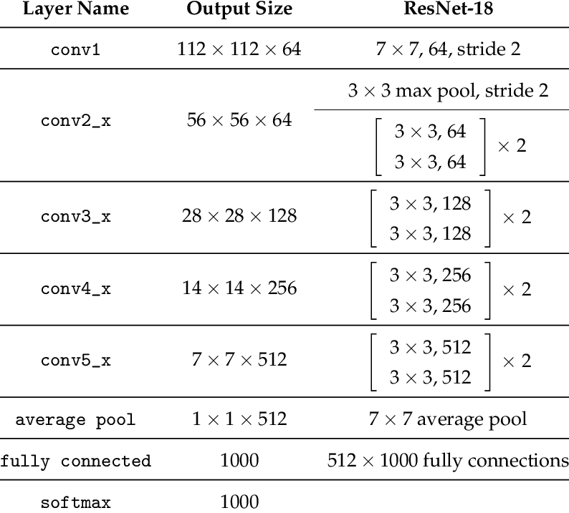

1. ResNet-18 Architecture.

Deep-layered architectures were designed to get more efficient results using the high number of convolutional layers. However, adding several deep layers to a network leads to a degradation of the output, introducing the problem of "Vanishing Gradient." During the training, algorithms such as gradient descent use backpropagation to calculate the loss function and update the weights. However, with numerous layers, the gradient calculation undergoes many multiplications, causing the gradient to get smaller and smaller, eventually "vanishing," resulting in the network's degraded performance [7].

So the accuracy of the model starts to get saturated when increasing the depth of the model, and to solve this problem of the “vanishing gradient,” residual blocks were introduced, which are the building blocks of a ResNet architecture. The ResNet architecture is formed by stacking these residual blocks on top of each other. These residual blocks are the shortcut connections, also called skip connection blocks, which work by connecting a layer's input directly to another layer's output after skipping a few connections, as we can see here in Fig. 1 [6].

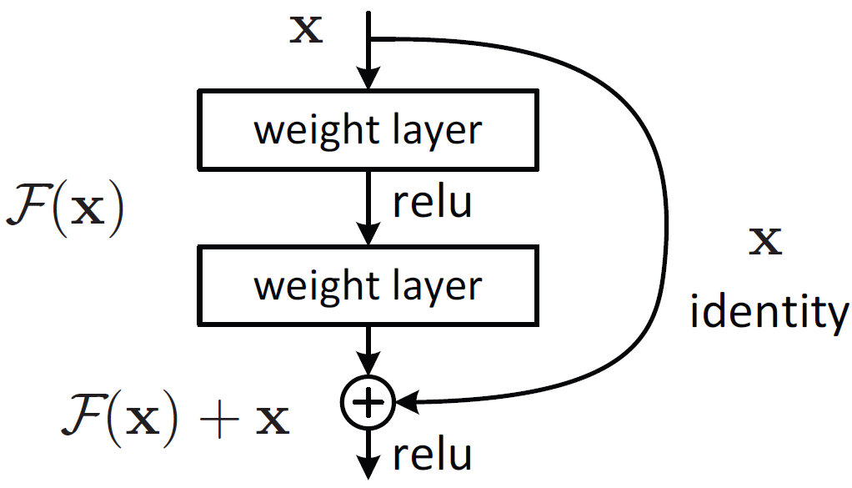

1. Residual Block.

## Baseline Model

For the baseline model, along with ResNet-18 as the architecture, the Cross-Entropy Loss function will be used to adjust the weights during the training since it works well with ResNet-18, and the formula is given in equation (1), where yi is the actual value, yi is the predicted value, and n is the output size.

$Cross Entropy Loss=-\sum_{i=1}^{n}{}y_{i}loglog \hat{y_{i}}$ (1)

The Adam optimizer will be used as the optimization algorithm. Adam, short for adaptive moment estimation, computes adaptive learning rates individually for various parameters. Adam combines two popular optimization methods: AdaGrad, which is good with sparse gradients, and RMSProp, which works well with non-convex optimization problems. Thus, it works so well with computer vision-related work [8]. As for the training, it will be done at a learning rate of 0.001 for 100 epochs.

1. Hyperparameters Of The Baseline Model

| **Hyperparameter** | **Value** |
| --- | --- |
| Optimizer | Adam |
| Loss Function | Cross-Entropy |
| Learning Rate | 0.001 |
| Number of Epochs | 100 |

## Dataset

The xBD dataset, collected from the xView website, is a precious resource for computer vision research. It offers a vast and diverse collection of satellite imagery encompassing urban and rural landscapes, with 850,736 annotated buildings spanning over the 45,362 km2 area of imagery, which are split for train, test, and holdout, respectively, with a split ratio of 80/10/10% [9]. Additionally, the dataset offers a fine-grained assessment of damage levels for buildings, spanning from "no damage" to "minor damage," "major damage," and even "destroyed." This comprehensive coverage of disaster scenarios and detailed damage classification truly sets the dataset apart, making it an invaluable asset for research and analysis in the field.

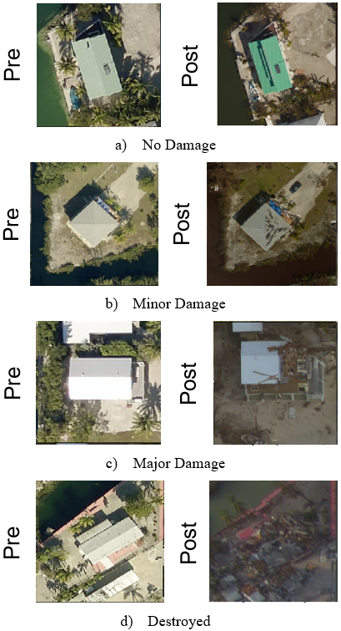

1. Different Types of Damages in the Dataset.

The xBD dataset team employed experts to annotate buildings in pre-disaster images using polygons. The ground truth polygons in post-disaster images were derived by projecting them from the pre-disaster images and aligning them based on satellite coordinates. For the post-disaster image annotation, damage evaluation experts were invited to label the polygons with four damage levels. Figure 1 provides sample images representing each damage level with pre- and post-images. The evaluation standard for post-disaster image annotation can be summarized as follows: Buildings showing no signs of water, structural damage, or burn marks are categorized as having no damage. Buildings labeled as destroyed have completely collapsed or are covered with water or mud. The minor damage classification is assigned when a building is partially burnt, surrounded by water, missing roof elements, or exhibits visible cracks. Major damage refers to a partial wall, roof collapse, or buildings surrounded by water. Although there is a distinct contrast between buildings with no damage and those that are destroyed, distinguishing between minor and majorly damaged buildings is often challenging when relying solely on the visual inspection of satellite images. [9]

Overall, the xBD dataset has been crucial in advancing computer vision research and enabling innovative solutions for real-world problems.

##### References

1. D. Kim, J. Won, E. Lee, K. R. Park, J. Kim, S. Park, H. Yang, and M. Cha, "Disaster assessment using computer vision and satellite imagery: Applications in detecting water-related building damages," Frontiers in Environmental Science, Korea, vol. 10, 2022.
2. R. F. Ahmad, A. S. Malik, A. Qayyum, and N. Kamel, "Disaster monitoring in urban and remote areas using satellite stereo images: A depth estimation approach," IEEE 11th International Colloquium on Signal Processing & Its Applications (CSPA), Kuala Lumpur, Malaysia, pp. 150–155, 2015.
3. S. N. K. B. Amit and Y. Aoki, "Disaster detection from aerial imagery with convolutional neural network," International Electronics Symposium on Knowledge Creation and Intelligent Computing (IES-KCIC), Surabaya, Indonesia, pp. 239–245, 2017.
4. F. Zhao and C. Zhang, "Building Damage Evaluation from Satellite Imagery using Deep Learning," IEEE 21st International Conference on Information Reuse and Integration for Data Science (IRI), Las Vegas, NV, USA, pp. 82–89, 2020.
5. "resnet18 - Torchvision main documentation," pytorch.org, https://pytorch.org/vision/main/models/generated/torchvision.models.resnet18.html (accessed Jun. 6, 2023).
6. K. He, X. Zhang, S. Ren, and J. Sun, "Deep Residual Learning for Image Recognition," IEEE Conference on Computer Vision and Pattern Recognition (CVPR), Las Vegas, NV, USA, pp. 770-778, 2016.
7. Y. Chandola, J. Virmani, H.S. Bhadauria, and P. Kumar, "End-to-end pre-trained CNN-based computer-aided classification system design for chest radiographs," Deep Learning for Chest Radiographs, pp. 117–140, 2021.
8. D. P. Kingma, and J. L. Ba, "Adam: A method for stochastic optimization," arXiv preprint arXiv:1412.6980, 2014.
9. R. Gupta, R. Hosfelt, S. Sajeev, N. Patel, B. Goodman, J. Doshi, E. Heim, H. Choset, and M. Gaston, “xBD: A Dataset for Assessing Building Damage from Satellite Imagery,” arXiv:1911.09296 [cs.CV], 2019.